**Total Pizzas Sold**

SELECT SUM(quantity) as Total_pizza_sold from pizza_sales

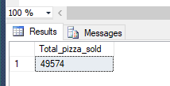

Total Orders:

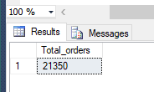

**Average Pizza per order**

SELECT CAST(CAST(SUM(quantity) as decimal(10,2)) / CAST(COUNT(DISTINCT order_id) AS decimal(10,2)) as decimal(10,2)) as Avg_pizzas_per_order from pizza_sales



**Daily Trend**

SELECT DATENAME(DW, order_date) as order_day, COUNT(DISTINCT order_id) as total_orders from pizza_sales

Group BY DATENAME(DW, order_date)

ORDER BY COUNT(DISTINCT order_id) DESC

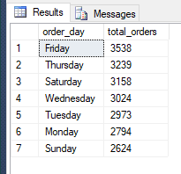

**Monthly Trend for Orders**

SELECT DATENAME(MONTH, order_date) as order_month, COUNT(DISTINCT order_id) as total_orders from pizza_sales

Group BY DATENAME(MONTH, order_date)

ORDER BY COUNT(DISTINCT order_id) DESC

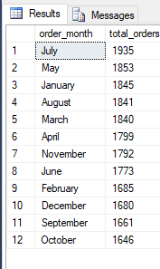

**% of Sales by Pizza Category**

select pizza_category, CAST(SUM(total_price) as decimal(10,2)) as total_revenue,CAST(SUM(total_price)*100 /(select SUM(total_price) from pizza_sales) as decimal(10,2)) as PCT from pizza_sales

Group by pizza_category

ORDER BY PCT DESC

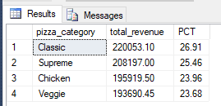

**% sales by pizza size**

select pizza_size, CAST(SUM(total_price) as decimal(10,2)) as total_revenue,CAST(SUM(total_price)*100 /(select SUM(total_price) from pizza_sales) as decimal(10,2)) as PCT from pizza_sales

Group by pizza_size

ORDER BY PCT DESC

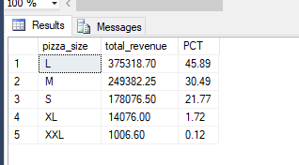

**Total Pizza Sold**

select pizza_category, SUM(quantity) as total_quantity_sold from pizza_sales

GROUP BY pizza_category

ORDER BY total_quantity_sold DESC

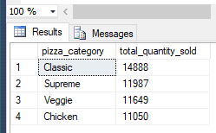

**TOP 5 Pizza by Revenue**

select TOP 5 pizza_name, SUM(total_price) as Total_revenue from pizza_sales

GROUP BY pizza_name

ORDER BY Total_revenue DESC

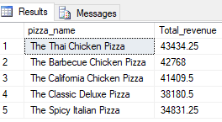

**Bottom 5 Pizzas by Revenue**

select TOP 5 pizza_name, ROUND(SUM(total_price), 2) as Total_revenue from pizza_sales

GROUP BY pizza_name

ORDER BY Total_revenue ASC

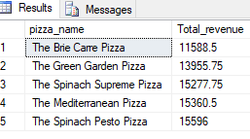

**Top 5 Pizzas by Quantity**

select TOP 5 pizza_name, SUM(quantity) as Total_Pizza_Sold from pizza_sales

GROUP BY pizza_name

ORDER BY Total_Pizza_Sold DESC

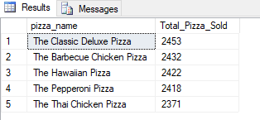

**Bottom 5 pizzas by Quantity**

select TOP 5 pizza_name, SUM(quantity) as Total_Pizza_Sold from pizza_sales

GROUP BY pizza_name

ORDER BY Total_Pizza_Sold ASC

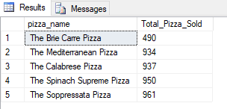

**Top 5 pizzas by Total Order**

select TOP 5 pizza_name, COUNT(distinct order_id) as Total_Orders from pizza_sales

GROUP BY pizza_name

ORDER BY Total_Orders DESC

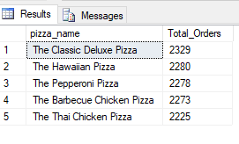

**Bottom 5 Pizzas by Order**

select TOP 5 pizza_name, COUNT(distinct order_id) as Total_Orders from pizza_sales

GROUP BY pizza_name

ORDER BY Total_Orders ASC

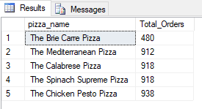

**With Filter :**

select TOP 5 pizza_name, COUNT(distinct order_id) as Total_Orders from pizza_sales

where pizza_category = 'Classic'

GROUP BY pizza_name

ORDER BY Total_Orders ASC

